ASSIGNMENT-1

|  |  |
| --- | --- |
| NAME | ABY ANTONY REX |
| ZONE | 4 |
| COLLEGE | GKMCET |

**STEP 1:**

Open the Remix in the chrome:

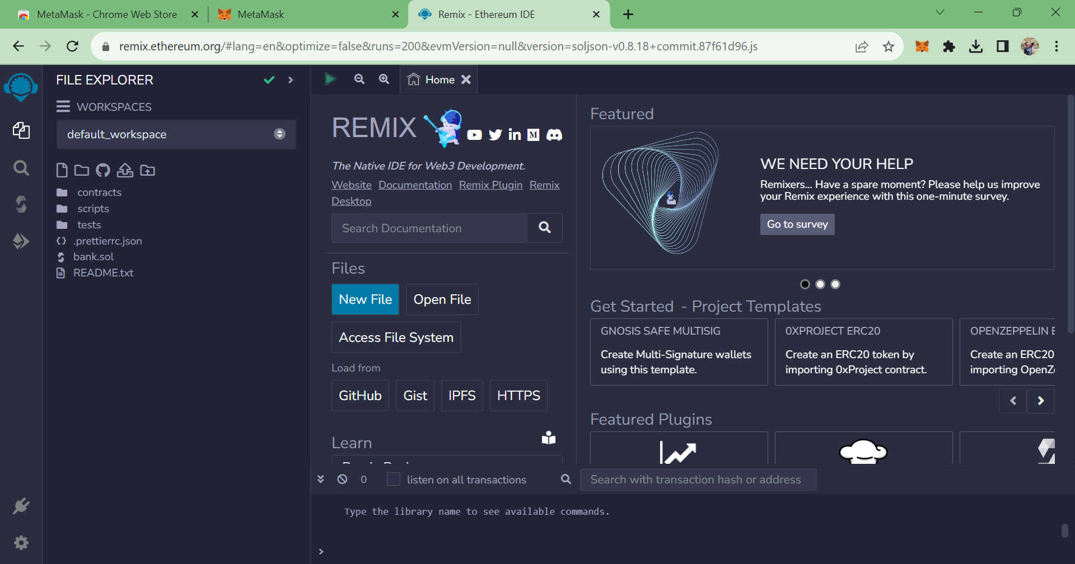

**STEP 2:**

Open the New file:

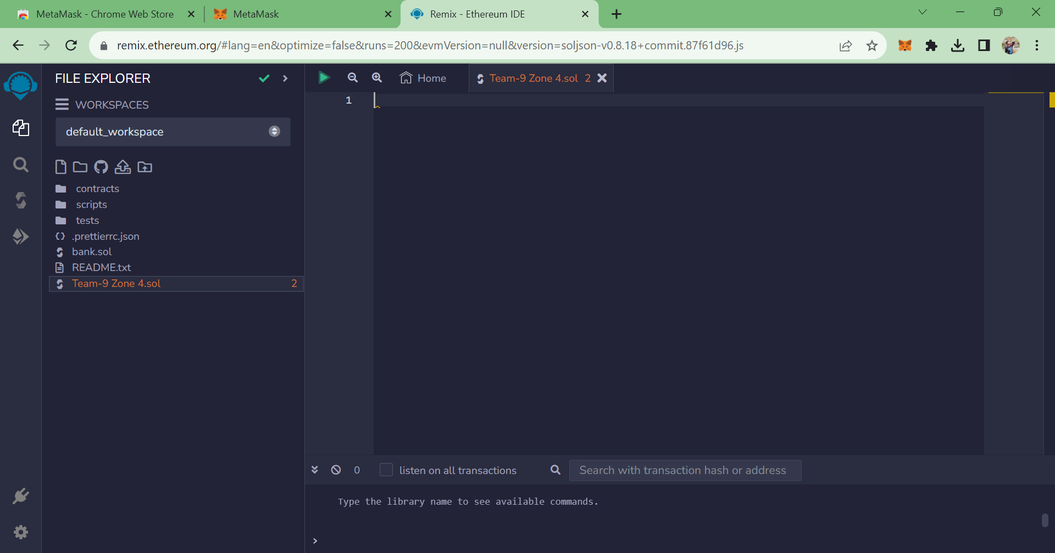

**STEP 3:**

Write and Compile the file:

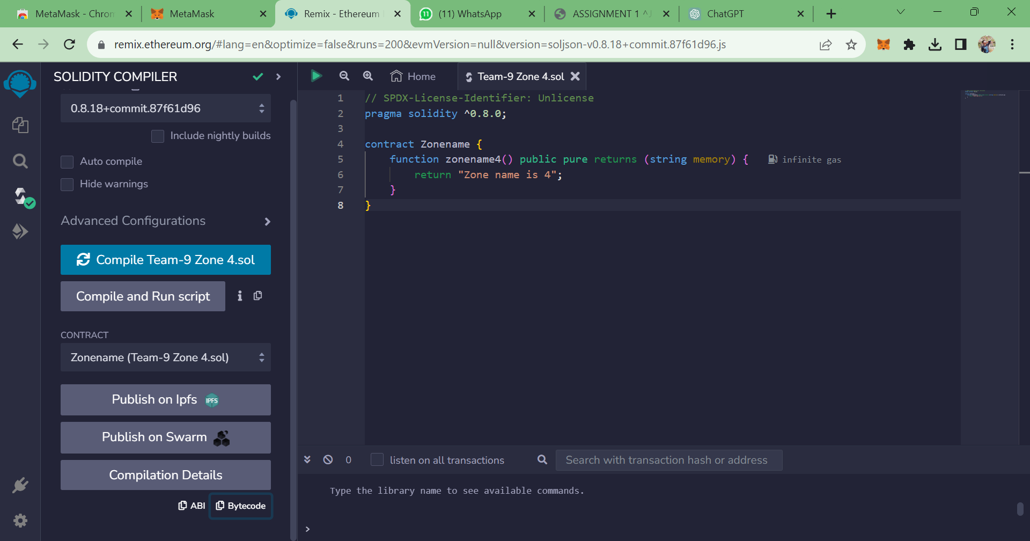

**STEP 4:**

Save the program and compile it to get the ABI and BYTE CODE:

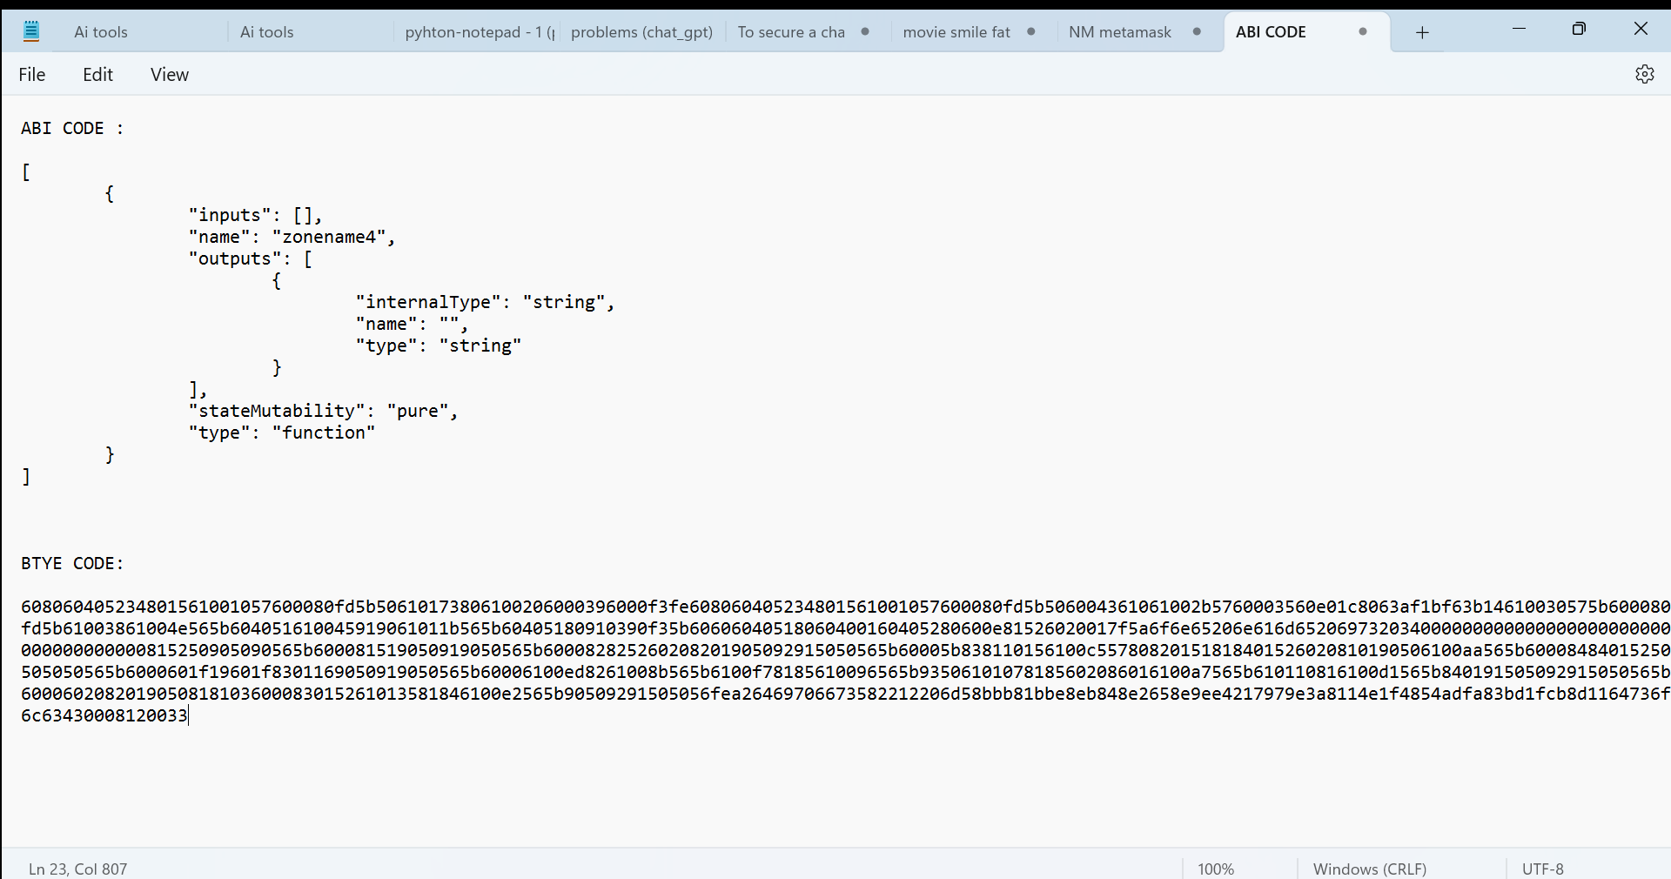

**STEP 5:**

Deploy the program and get the output:

